# WRS Permission Levels and Groups

## Remember to use a SQL Server Alias

### Site Permissions

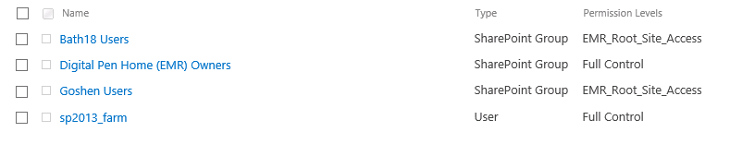

### Permission Levels

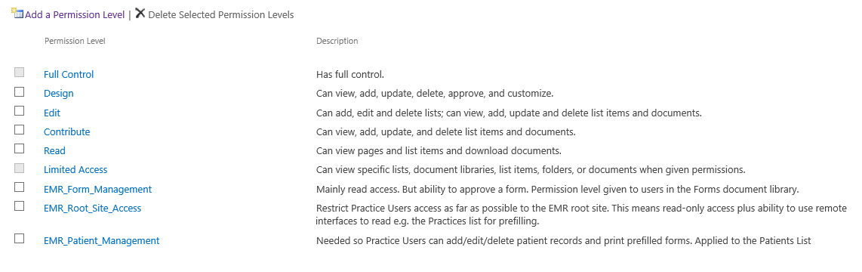

## Useful Function

Go to People and Groups, Select GoshenUsers, then select Settings => View Group Permissions

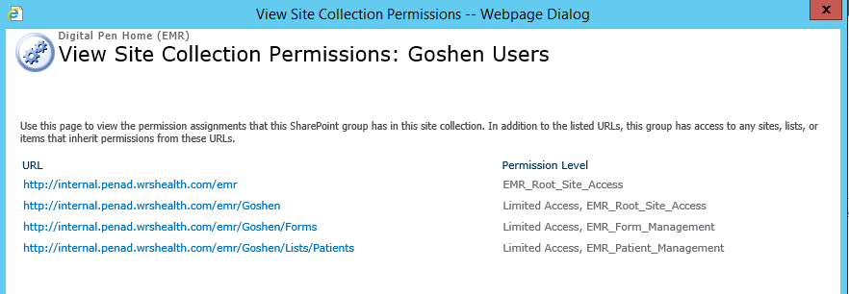

|  |  |  |  |
| --- | --- | --- | --- |
| Permission Level | List Permissions | Site Permissions | Notes |
| **EMR_Root_Site_Access**  Restrict Practice Users access as far as possible to the EMR root site. This means read-only access plus ability to use remote interfaces to read e.g. the Practices list for prefilling. | View Items  (Needed to display WRS Health Logo in sub site) | View Pages  (Needed to display WRS Health Logo in sub site and Qucik Links)  Use Remote Interfaces, Open | Essentially read-only access. The default permission granted to a subsite user group in the EMR root site. Extra permissions are added on a list/library basis in the subsite i.e. Forms and Patients and as required. |
| EMR_Form_Management Mainly read access. But ability to approve a form. Permission level given to users in the Forms document library. | Edit Items, View Items, View Application Pages | View Pages, Use Remote Interfaces, Open | May change once approval workflow is implemented. |
| EMR_Patient_Management Mainly read access. But ability to edit is given so that practice users can add new Patient. Permission level given to practice users in the Patients list. | Add, Edit, Delete Items, View Items, View Application Pages | View Pages, Use Remote Interfaces, Open |  |
|  |  |  |  |

### EMR Root Site - Groups

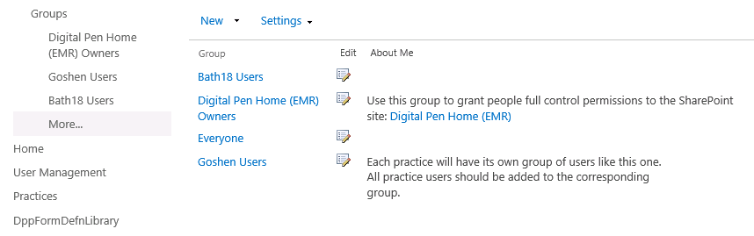

### EMR Owners Group

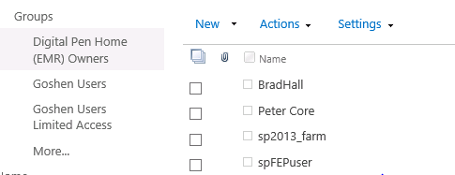

### Goshen User Group

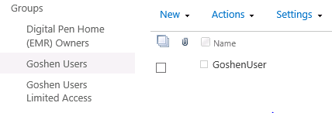

## Customer Subsites

Subsites have Unique Permissions

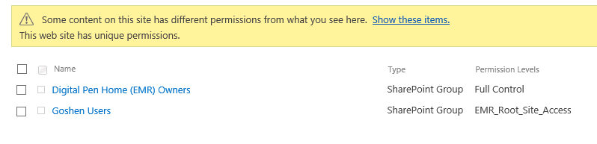

**New Forms** has unique permissions (but this could change if approval implemeted via workflow)

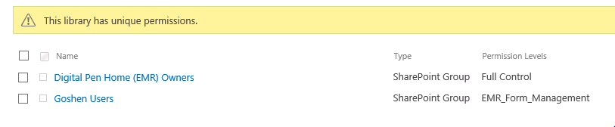

As does **Patients** list

